**Query:**

SELECT LPAD(cast(b.BRANCH_ZIP as STRING),5,'0') as `Zip Code`, SUM(cc.TRANSACTION_VALUE) as `Total Transaction Value`

FROM CDW_SAPP_D_BRANCH b

INNER JOIN CDW_SAPP_F_CREDIT_CARD cc ON b.BRANCH_CODE=cc.BRANCH_CODE

GROUP BY b.branch_zip

ORDER BY `Total Transaction Value` DESC

LIMIT 20;

**Visualization:**

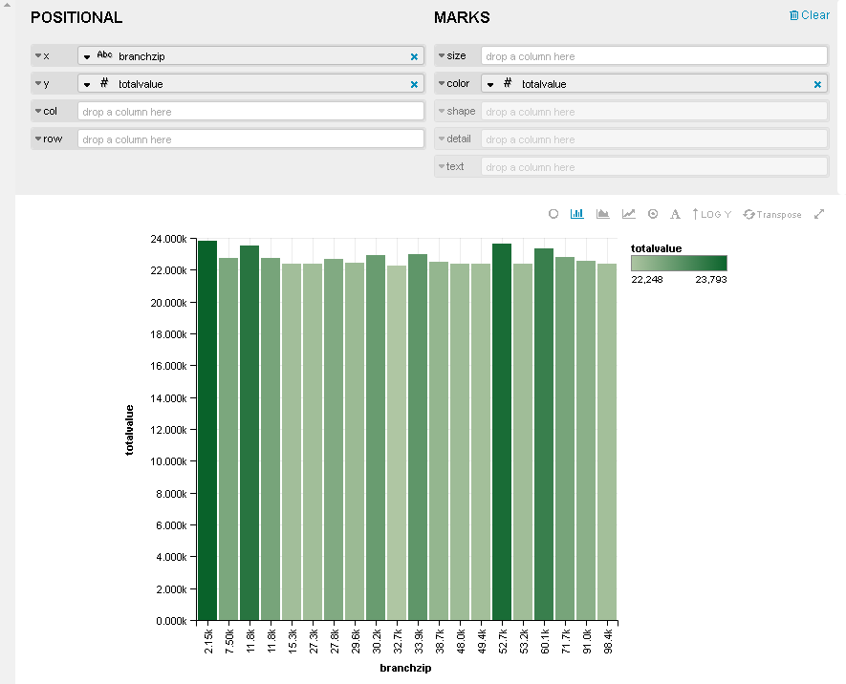

I couldn’t find a way to display the entire zip as a string rather than it being abbreviated as a number. My machine stopped visualizing my query, so I ended up using someone else’s machine and query that had identical values, but different aliases (and no formatting) than in my query.

**Query:**

Select

concat('$', sum(cc.TRANSACTION_VALUE) ) as `Total Value`,

cc.TRANSACTION_TYPE as `Type`,

t.QUARTER as `Quarter`

FROM CDW_SAPP_F_CREDIT_CARD cc

INNER JOIN CDW_SAPP_D_TIME t on cc.TIMEID=t.TIMEID

GROUP BY cc.TRANSACTION_TYPE, t.QUARTER;

**Visualization:**

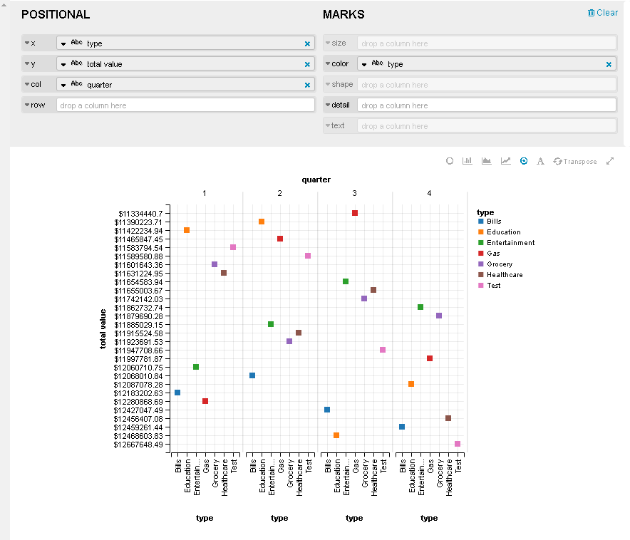

Positional x and column can be switched, depending on whether you’re more interested in per-quarter or per-type visualization emphasis